Requirement Specification Document

Student’s name: Ling_Cheng Yan

Project’s idea: Raspberry Pi Image Recognition

**User’s perspective:** There is a camera on the machine, and the camera can capture the image of the real world object, then it can recognize the image. For example, if there is a car on the road, you can use the camera to capture the image of the car, and then there will show the information about the image, like what kind of car it is.

*(illustration diagram)*

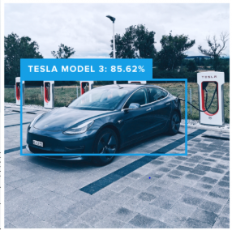

**Designer’s perspective:** There is a camera on the Raspberry Pi, then we use python programming to design how to capture the image and how to recognize the image. We may also use the tools like OpenCV to deal with the image information.

**Constraints:** The cost of the camera may be high, also you have to have the concepts of deep learning and machine learning